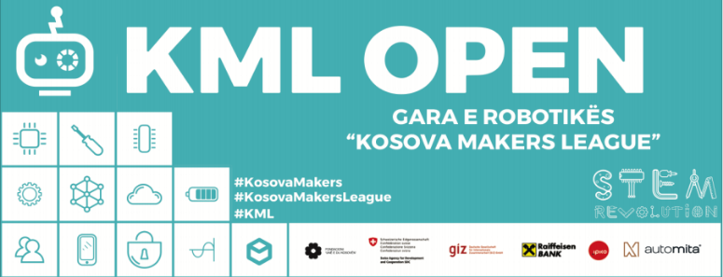
INSTRUCTIONS
FOURTH CHALLENGE
Date of Announcement: 23.04.2019

KML Open - The Fourth Round will be online and will be held on April 23-30, 2019.

1.SUBSTANTIAL INSTRUCTIONS
1.1 Starting the Robot

1.1.1 The robot must be placed in such a way that the black line sensor is at the beginning of the line (path).
1.1.2 The start of the robot should be done by pressing the button on the robot.
1.1.3 If the robot is properly ignited, the competitor wins 20 points as the rating table shows.
1.1.4 If the robot is powered in any other way, the competitor does not win 20 points, but can continue the race.
1.1.5 If the robot comes out of the line, the student can turn the robot back to the beginning of the quadrant where the robot has diverted to the beginning of the next quarter and continue the race. It does not lose points but loses just in time.

1.2 The tunnel on the map
1.2.1 The scheme you have received, you should also attached a tunnel through which the robot will pass.
1.2.2 In the tunnel segment, a pre-made tunnel must be placed with the cardboard material to which you can attach other decorative materials.
1.2.3 The tunnel should be made according to these dimensions: width 22 cm - 25 cm, height 12cm - 15cm and length 25cm - 30cm.
1.2.4 During black line tracking, the robot must go inside the tunnel. While the robot is walking inside the tunnel it will detect the darkness signal inside it through the light sensor and ignite and stop the RGB diode in the red color. If the robot stops and ignites the red RGB diode, the competitor wins 10 points.
1.2.5 If the RGB diode is not illuminated in red, is not lit or the diode remains active even after the tunnel leaves, the competitor does not gain 10 points but may continue the race.
1.2.6 Also, along the path that the robot does inside the tunnel, he must release and stop a sound at the same time as the red light. If the robot releases and stops the sound, the contestant wins 10 points.

1.2.7 If the robot does not sound or its sound remains active and after the exit from the tunnel, the competitor does not win 10 points but can continue the race.

1.3 Continuation of the Path
1.3.1 Continuing the path is called when the robot is able to pass through the tunnel and continue to follow the black line to the end.
1.3.2 At the end of the path the robot will encounter an obstacle. The robot will detect the obstacle and turn right at 90 degrees angle, then move in that direction and stop at the STOP sign. If the robot passes this stage successfully, the contestant wins 30 points.
1.3.3 If the robot does not pass the stage successfully, meaning it does not detect the obstacle, does not turn 90 degrees, does not continue to move in that direction and stops at the STOP sign, the competitor does not win 30 points and the race for the robot ends there, with as much points as he has managed to gather.

1.3.4 The STOP sign shall be located parallel to the tunnel.
1.3.5 The timer starts when the competitor presses the robot button and ends when the robot stops at the STOP sign after detecting the obstacle at the bottom of the black line.
1.3.6 The main criterion for team evaluation is the collection of points, while the duration of the robot is only to make the difference between teams with the same points. (For example, if Team X has collected 330 points and completed the race for an average of 35 seconds, while Team Y has also collected 330 points, but has completed the race for an average of 40 seconds, then Team X will be in the first place While in the same case if Team X has collected 280 points and finished the race for 35 seconds, while Team Y has collected 300 points and finished the race for 40 seconds, Team Y will be in the first place. efficiency will be the main criterion of evaluation).

1.4 The role of the robot

Unlike other times, this time we thought your robot would appear a little different. Each robot should have its role to perform a certain service.

1.4.1 Cleaner Robot

1.4.1.1 The cleaning robot will serve as a cleaner for the route.
1.4.1.2 The robot suit can be made from cardboard.
1.4.1.3 When creating a suit, be careful and avoid covering any sensor that the robot owns, otherwise your robot may encounter problems during the challenge.
1.4.1.4 The size of the suit shall be adapted to the conditions of the road to be passed and not to affect its performance.
1.4.1.5 Along the way the robot is going to follow, it must remove garbage from the road. Materials that will serve as road garbage can be varied (paper, paperboard, plastic, cotton etc)
1.4.1.6 If the robot suit has assisted him in successfully completing the service, the competitor wins 20 points. If the suits did not assist in performing the service successfully, the contestant does not win 20 points but can continue the race.

1.4.2 Servant Robot

1.4.2.1 The servant robot will assist in the transfer of different products.
1.4.2.2 The robot suit may be made of cardboard.
1.4.2.3 When creating a suit, be careful and avoid covering any sensor that the robot owns, otherwise your robot may experience problems during the challenge.
1.4.2.4 The size of the suit should be adapted to the road conditions that will pass and not affect its performance.
1.4.2.5 On the way the robot will pursue, it has to carry different products. The products can be drawn and then cut or made ready but not heavy (paper, cardboard, plastic etc.).
1.4.2.6 If the robot suit has helped him successfully perform the service, the contestant wins 20 points. If the suits did not assist in performing the service successfully, the contestant does not win 20 points but can continue the race.

1.4.3 Informative Robot

1.4.3.1 The information robot will help in sharing various information. The way that the robot shares information remains in your creativity.
1.4.3.2 The costume can be made from cardboard.
1.4.3.3 When creating a suit, be careful and avoid covering any sensor that the robot owns, otherwise your robot may experience problems during the challenge.
1.4.3.4 The size of the suit should be adapted to the road conditions that will pass and not affect its performance.
1.4.3.5 The way the robot is going to follow, it should inform others of the various events through which text can be attached to images.
1.4.3.6 If the robot suit has helped him successfully perform the service, the contestant wins 20 points. If the suits did not assist in performing the service successfully, the contestant does not win 20 points but can continue the race.

1.4.4 Robots artist

1.4.4.1 The artist's robot will have to show its artistic side while following the path.
1.4.4.2 Costume can be made from cardboard material to be attached to dyestuffs as a marker, a brush for coloring, and so on. The number of colorants or the way you put them remains your creative side.
1.4.4.3 When creating a suit, be careful and avoid covering any sensor that the robot owns, otherwise your robot may experience problems during the challenge
1.4.4.4The size of the suit should be adapted to the road conditions that will pass and not affect its performance.
1.4.4.5 Colorant, marker, colored brushes or whatever else should be cared for and be sure not to affect its performance.
1.4.4.6 If the robot has managed to show its function successfully, the contestant wins 20 points. If the suits did not assist in performing the service successfully, the contestant does not win 20 points but can continue the race.

2. PROCEDURAL INSTRUCTIONS FOR CHALLENGE

2.1 All school teams need to record their performance with a single video and upload it no later than April 30 in the Robotics Database on the Vimeo platform.
2.2 All teams in the video must wear Kosova Makers League t-shirts.
2.3 The time during which each robot passes the path should appear in the video of the challenge.
2.4 All mentors evaluate their teams and complete the form of evaluation in google documents.
2.5 Any video upload after 23:59 of the 30th of April will not be evaluated.
2.6 All school teams will perform at their school premises
2.7 Only photos taken during exercises or on the day of video recording can be posted to the KML group on the Facebook platform.
2.8 From April 23 to April 30, mentors of the BONEVET Foundation will check the preliminary results as well as the video recordings and will announce the final results for the Third Round, where again there will be 48 hours of appeal time.
2.9 Winners of the Third Round will be invited to the first week of May to accept the prizes.
2.10 Uploading Videos to VIMEO takes place in the KML third round group found on this link: https://vimeo.com/groups/kml4

*Explanation: The pictures displayed below from the platform Vimeo show the third round group. Note that the video upload procedure is the same but now you have a different group for the fourth round, that you will enter by clicking the link above.
2.11 Once you have received the link of Kosova Makers League group for the current challenge, you need to join this group. To be a part of the group please click Join this group.
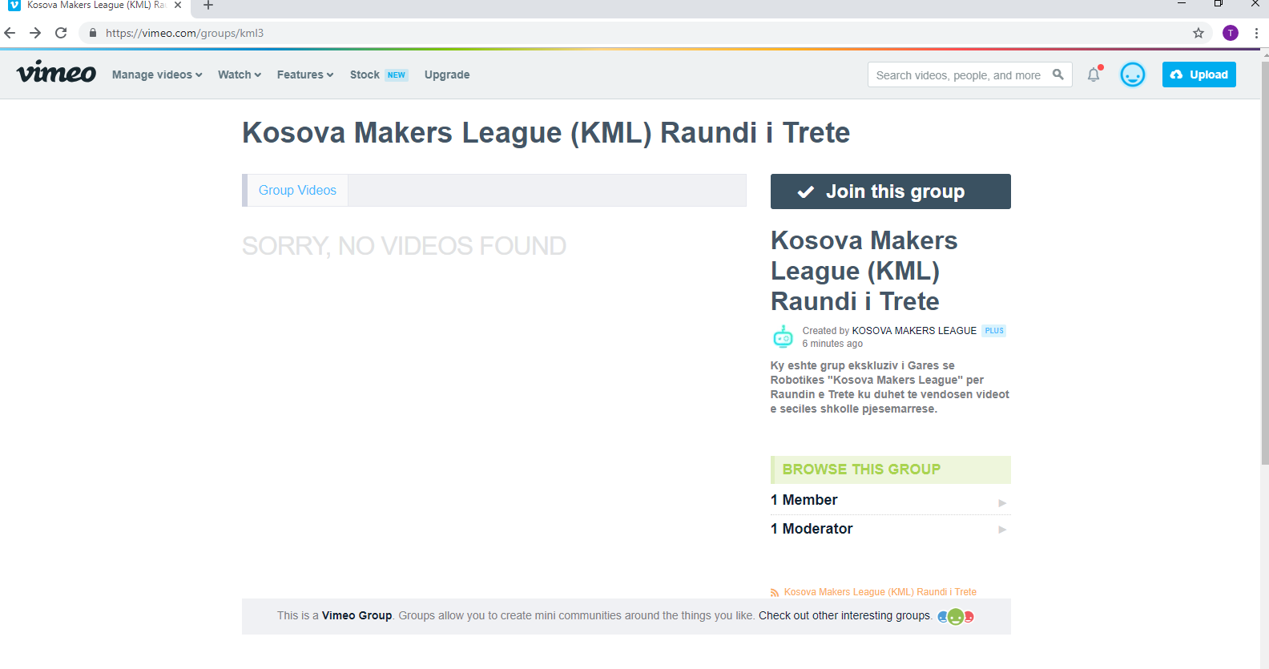
Picture 1

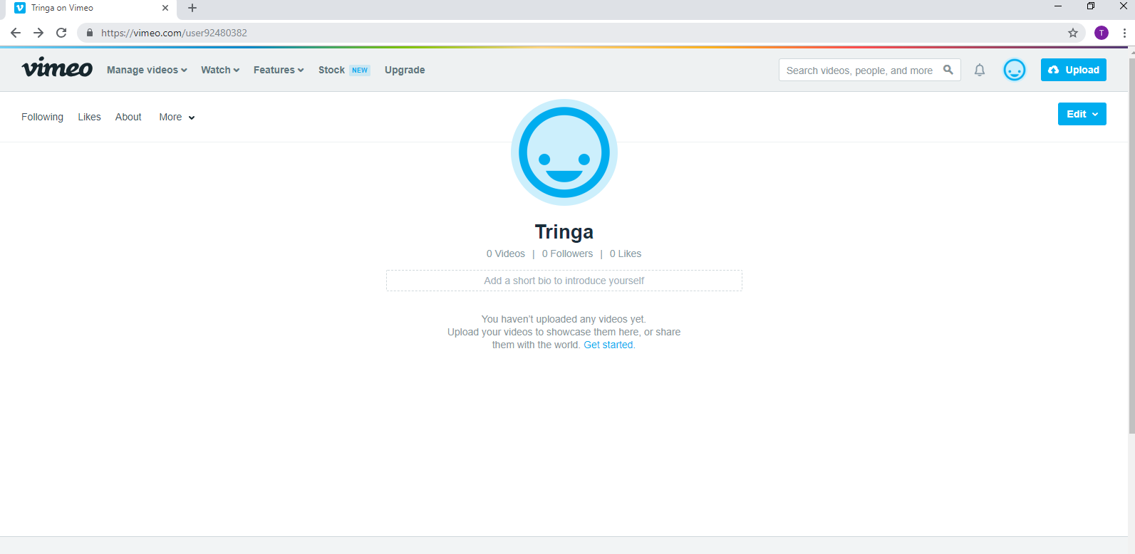
2.12 Then go to your profile on Vimeo. On the right side of the page you will see the Upload button, click on it.
Picture 2

2.13 Then click Or Choose Files.
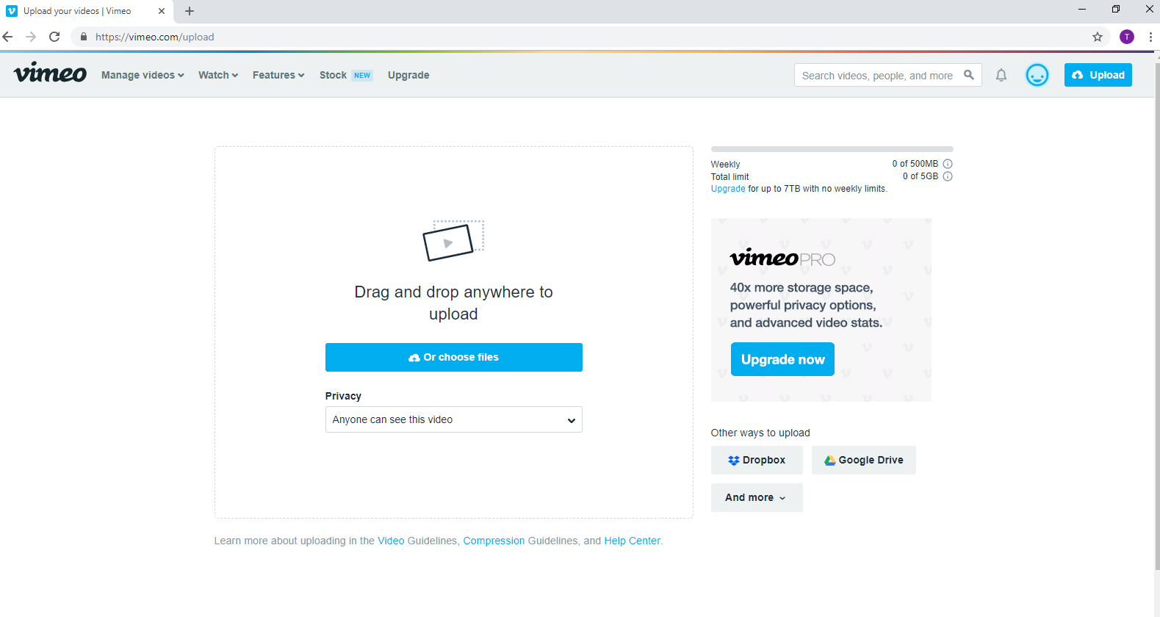
Picture 3

2.14 After clicking, a new window will appear, where you will need to select your challenge video.
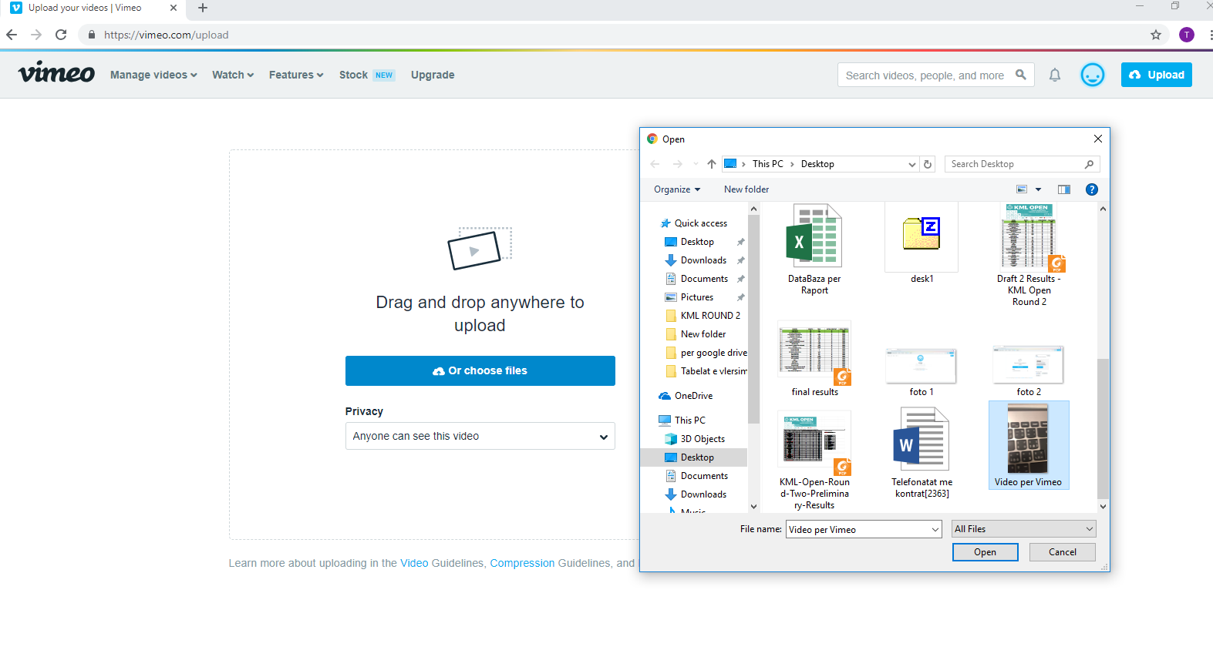
Picture 4

2.15 After uploading the video you have to create the title of the video, this is done in the Title box. Create the title as follows: City / Location - School-Cycle (Low, High) - Student Name. The example used in the photo, "Pristina- Gjergj Fishta- Low Cycle -Tringa Kasneci". Do not enter anything in the "Description" field. In the "Tags" box, place these: KosovaMakers, KosovaMakersLeague, KMLOpen, KML18. Make sure that you put a comma after each word. Finally, press the Save button.
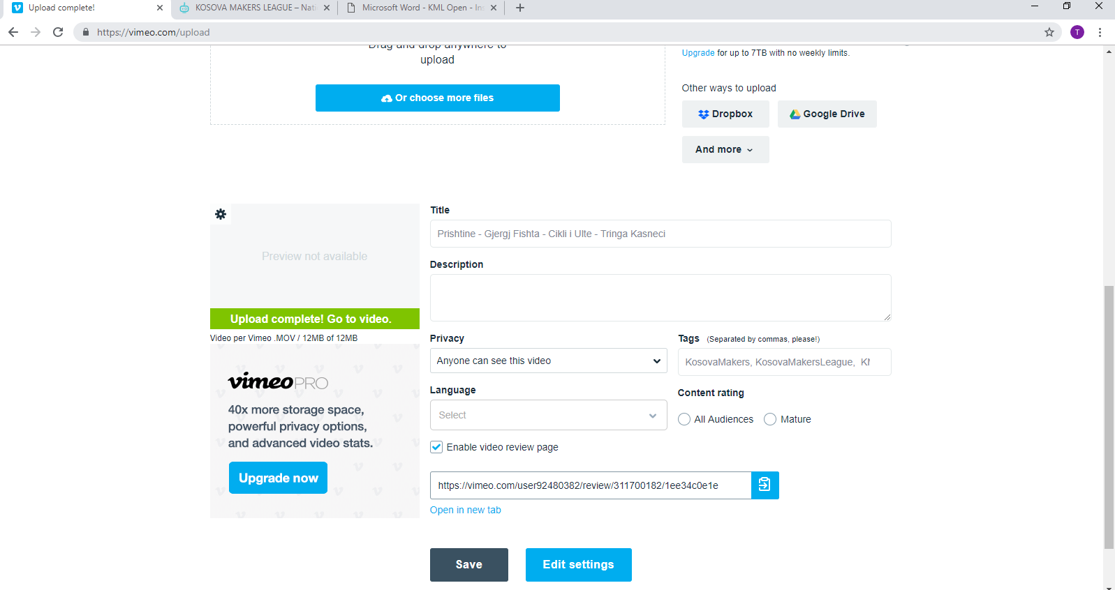

Picture 5
2.16 After clicking Save, in the same page click Edit Settings.

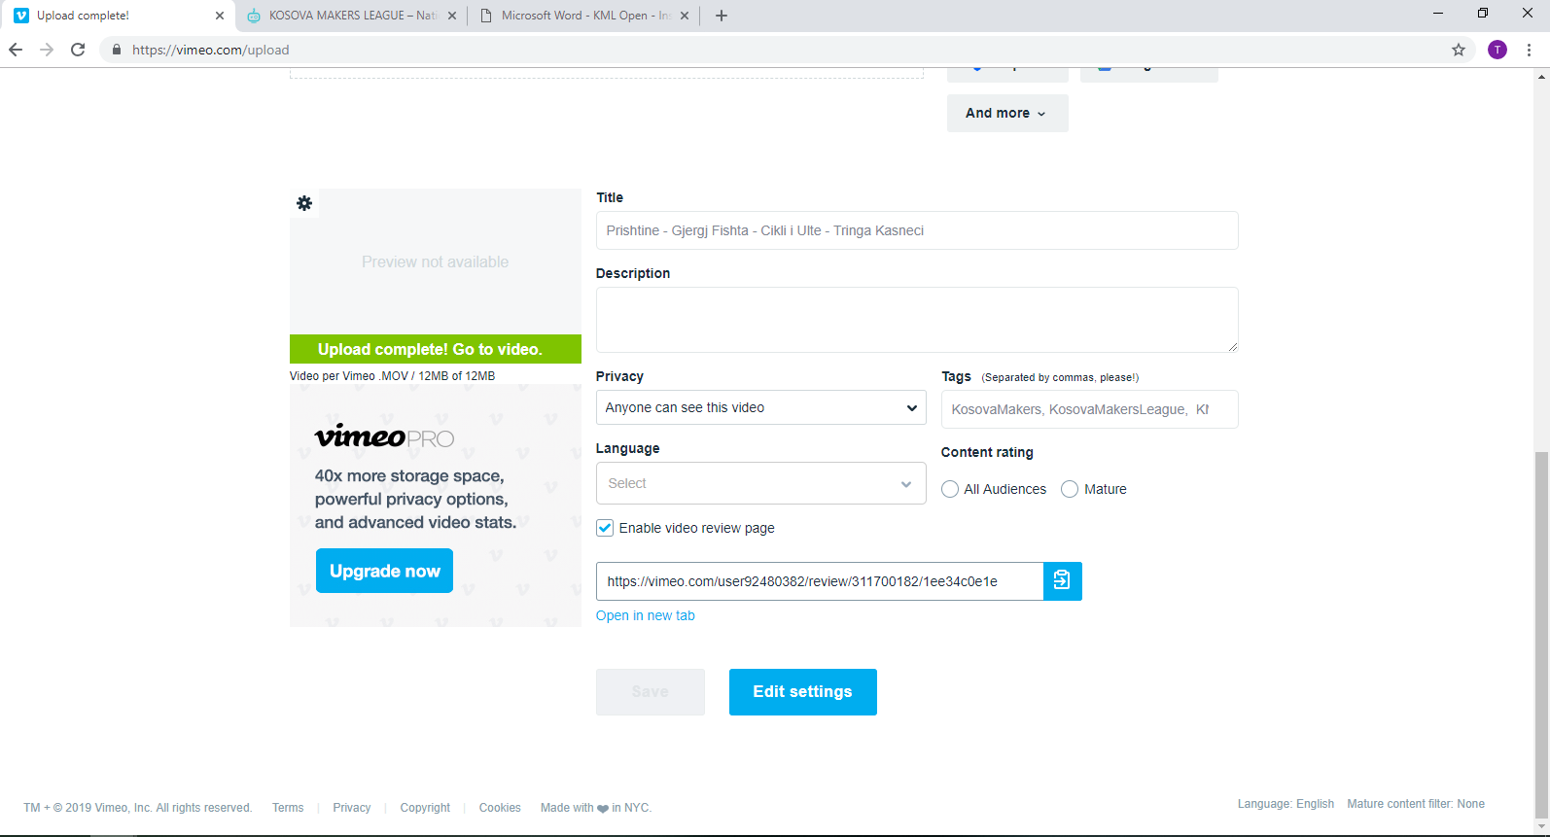
Picture 6
2.17 In the menu that will appear, select the General menu and the submenu Collections. Once you are part of the group, in the Groups section you will also see the group of Kosova Makers League, click on the group and save the changes with the Save button.

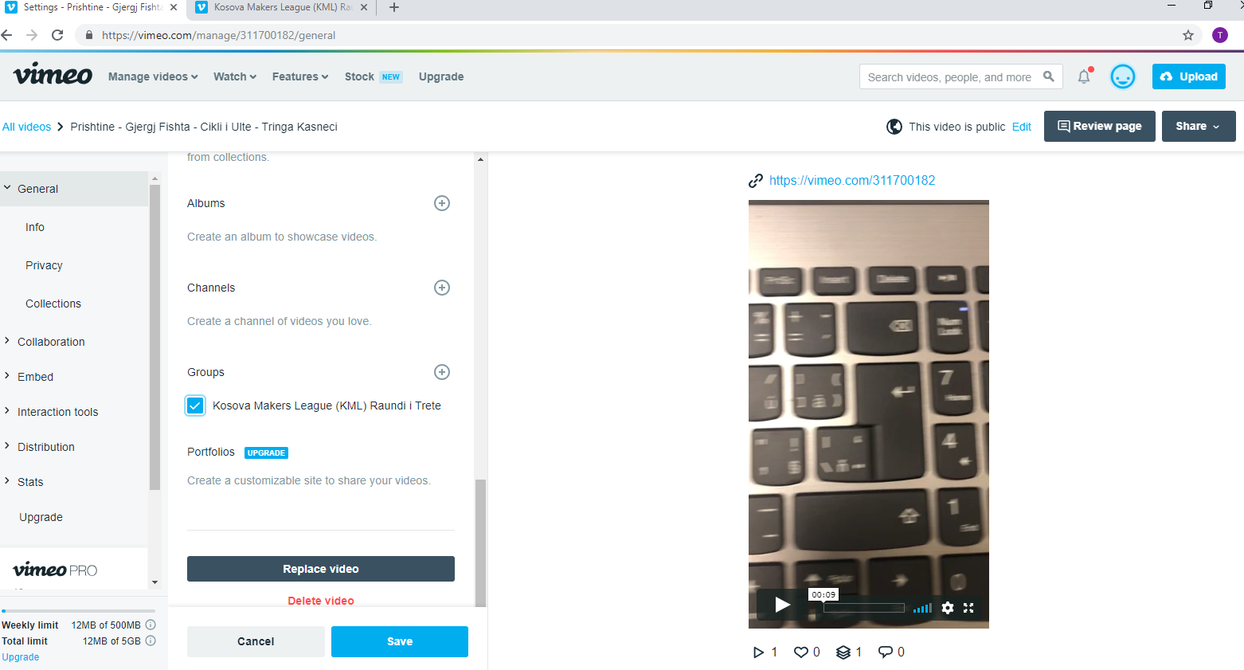

Picture 7
2.18 To verify if your video has been uploaded to the Kosova Makers League group. Go back to the group, and in the Search button type some keywords from your video title, if your video appears, the process has been successfully completed.
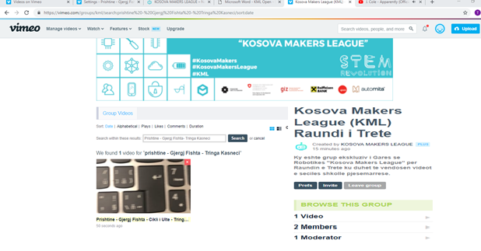

Picture 8

2.19 2.19 Uploading Results to Google Form
2.20 To fill out the scores of students please log in:
https://docs.google.com/forms/d/e/1FAIpQLSeGGNaPmiAYBJ8VTakVRxTS09kfrWbH4PCTkmXKnk58ds-wxQ/viewform
2.21 Once the page has been opened you must complete the required data and at the end of the process touch the button at the bottom of the page 'SUBMIT'.

